General Description

UHFREADER18 is a high performance UHF RFID integrated reader. It is designed upon fully self-intellectual property. Based on proprietory efficient DSP algorithm, it supports fast tag read/write operation with high identification rate. It can be widely applied in many RFID application systems such as logistics, access control, anti-counterfeit and industrial production process control system.

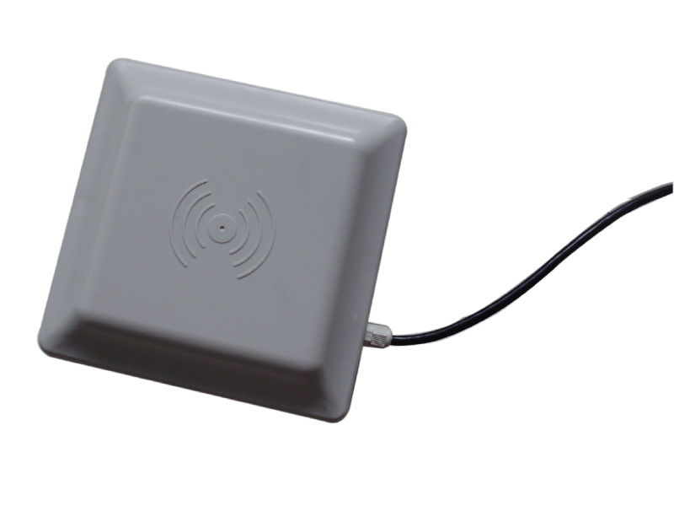
FEATURES
- Self-intellectual property;
- Support ISO18000-6B, ISO18000-6C(EPC C1G2) protocol tag;
- 902~928MHz frequency band(frequency customization optional);
- FHSS or Fix Frequency transmission;
- RF output power up to 30dbm(adjustable);
- 8dbi/12dbi antenna optional with effect distance up to 3m/10m*;
- Support auto-running, interactive and trigger-activating work mode;
- Low power dissipation with single +9 DC power supply;
- Support RS232, RS485, Wiegand interface;
* Effective distance depends on antenna, tag and environment.
CHARACTERISTICS
- Absolute Maximum Rating
ITEM | SYMBOL | VALUE | UNIT
Power Supply | VCC | 16 | V
Operating Temp. | T_{OPR} | -10~+55 | ℃
Storage Temp. | T_{STR} | -20~+75 | ℃
- Electrical and Mechanical Specification
Under T_{A}＝25℃，VCC＝+9V unless specified
ITEM | SYMBOL | MIN | TYP | MAX | UNIT
Power Supply | VCC | 8 | 9 | 12 | V
Current Dissipation | I_{C} |  | 350 | 650 | mA
Frequency | F_{REQ} | 902 |  | 928 | MHz

Interface
Item | Comment
Red | +9V
Black | GND
Yellow | Wiegand DATA0
Blue | Wiegand DATA1
Purple | RS485 R+
Orange | RS485 R-
Brown | GND
White | RS232 RXD
Green | RS232 TXD
Grey | Trigger input（TTL level）
* Optional model named as UHFReader18TCP with TCP/IP interface is also available.

